Elton, Gruber, Brown, and Goetzmann
Modern Portfolio Theory and Investment Analysis, 9th Edition
Solutions to Text Problems: Chapter 27

Chapter 26: Problem 1

A.
The points on a Predictive Realization Diagram would have the following coordinates (where P_{i} = predicted change in earnings and R_{i} = realized change in earnings):

Industry/Firm | P_{i} |  |  |  | R_{i}
A1 |  | 0.05 |  |  |  | 0.00
A2 |  | 0.05 |  |  |  | 0.03
A3 |  | 0.75 |  |  |  | −0.25
B4 |  | 0.04 |  |  |  | 0.06
B5 |  | 0.05 |  |  |  | 0.04
B6 |  | 0.65 |  |  |  | 0.20
B7 |  | −0.01 |  |  |  | −0.01
C8 |  | .070 |  |  |  | 0.40
C9 |  | −0.03 |  |  |  | −0.01
C10 |  | −0.02 |  |  |  | 0.02

While there are only ten points on the Prediction Realization Diagram, certain tendencies can be detected. It is very clear from the diagram that analysts in this brokerage firm systematically overestimate earnings. Their forecasts have a strong upward bias. The second marked tendency is fro the degree of overestimation to grow as positive increases in earnings become larger. Similarly, there is a slight (based on one observation) tendency for analysts to overestimate the size of a decrease in earnings when a decrease takes place. The analysts misestimated the direction of a change in earnings in only two out of the ten cases.

B.
Recall from the text that, for the computation of mean square forecast error (MSFE), the results are the same whether we use predicted levels or predicted changes in earnings. We will do the MSFE analysis using levels and the following formula:

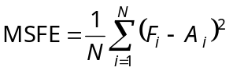

where F_{i} is the forecasted level of earnings for firm i per share A_{i} is the actual earnings per share for firm i.

Industry/Firm | F_{i} |  |  |  | A_{i} |  |  |  | 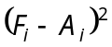
A1 |  | $1.10 |  |  |  | $1.05 |  |  |  | 0.0025
A2 |  | $1.37 |  |  |  | $1.35 |  |  |  | 0.0004
A3 |  | $4.25 |  |  |  | $3.25 |  |  |  | 1.0000
B4 |  | $2.10 |  |  |  | $2.12 |  |  |  | 0.0004
B5 |  | $2.13 |  |  |  | $2.12 |  |  |  | 0.0001
B6 |  | $3.25 |  |  |  | $2.80 |  |  |  | 0.2025
B7 |  | $1.06 |  |  |  | $1.06 |  |  |  | 0.0000
C8 |  | $2.70 |  |  |  | $2.40 |  |  |  | 0.0900
C9 |  | $0.52 |  |  |  | $0.54 |  |  |  | 0.0004
C10 |  | $1.16 |  |  |  | $1.20 |  |  |  | 0.0016
 |  |  |  |  |  |  |  |  | Sum | 1.2979

Therefore:

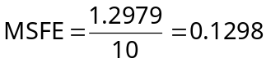

C.
From the text, we know that the MSFE can be decomposed by level of aggregation as follows:

where the first term measures the forecast error due to all analysts misestimating the average earnings in the economy, the second term measures the error due to individual analysts misestimating the differential earnings for particular industries from the average for the economy, and the third term measures the error due to individual analysts misestimating the differential earnings for particular companies within an industry from the average for that industry. So we have:

Error due forecasting sector of economy:

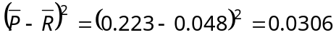

Error due forecasting each industry:

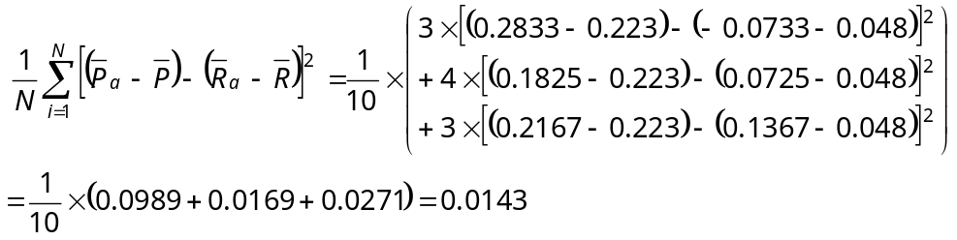

Error due forecasting each firm:

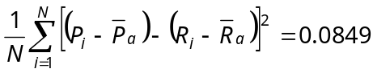

Notice that the sum of the three components equals 0.1298, which is the total MSFE we calculated earlier.

To express each component as a percentage of the total MSFE, simply divide each component by 0.1298 and multiply by 100:

Percent of forecast error due to forecasting sector of economy = 23.57%

Percent of forecast error due to forecasting each industry = 11.02%

Percent of forecast error due to forecasting each firm = 65.41%

D.
1. MSFE for each analyst:

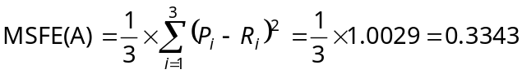

MSFE(B) = 0.0508

MSFE(C) = 0.0307

2. MSFE decomposition for each analyst:

For analyst A,

Industry Error = 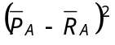 = 0.1272

Company Error = 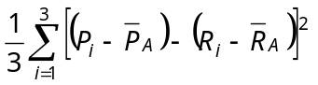
= 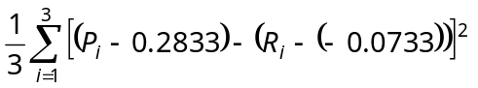
= 0.2071

% Industry Error = 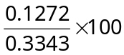 = 38.05%

% Company Error = 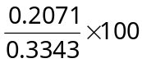 = 61.95%

For analyst B,

Industry Error = 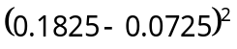 = 0.0121

Company Error = 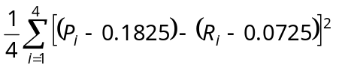
= 0.0387

% Industry Error = 23.8%

% Company Error = 76.2%

For analyst C,

Industry Error = 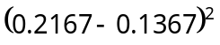 = 0.0064

Company Error = 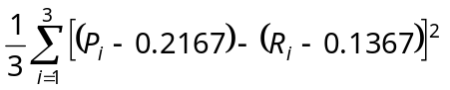
= 0.0243

% Industry Error = 20.8%

% Company Error = 79.2%

E.
The calculations in this part use N, not N − 1, in the denominator for variances.

Error Due To Bias = 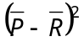 = 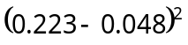 = 0.0306

Error Due To Variance = 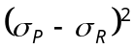 = 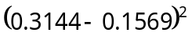 = 0.0248

Error Due To Covariance = 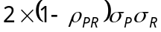 =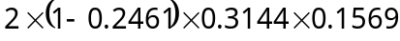 = 0.0744

% Error Due To Bias = 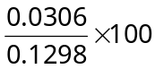 = 23.57%

% Error Due To Variance = 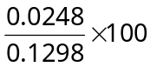 = 19.11%

% Error Due To Covariance = 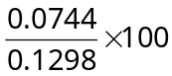 = 57.32%

